Chapter 9, Solution 27.

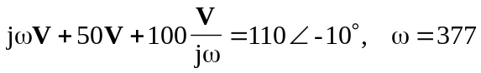
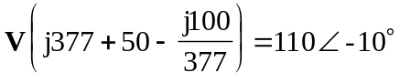
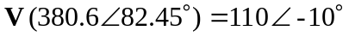
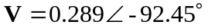

Therefore, v(t) = 289 cos(377t – 92.45) mV.

